A000-Eur-Czech Republic-Dolní Věstonice-Figurine-Mammoth-Ceramic-29,000-22,000 BP



Fig. 1. Czech Republic-Dolní Věstonice-Figurine-Mammoth-Ceramic-29,000-22,000 BP

**Formal Label:** Czech Republic-Dolní Věstonice-Figurine-Mammoth-Ceramic-29,000-22,000 BP **Display Description**: This ceramic mammoth from Dolní Věstonice, Moravia, in the Czech Republic, was found in a test pit by H. Freising in 1923 on the hill of Pollau 549 m (1,801 ft) asl, and was dated to 29,000-22,000 BP by stratigraphy. This find led K. Absolon to excavate the site for another 15 years and to discover ca 10,000 ceramic fragments of the Gravettian period.

**Accession Number: A000**

**LC Classification:** GN772.22.C95

**Date or Time Horizon:** 29,000-22,000 BP

**Geographical Area:** Moravia in the Czech Republic, on the hill of Pollau.

**Map, GPS 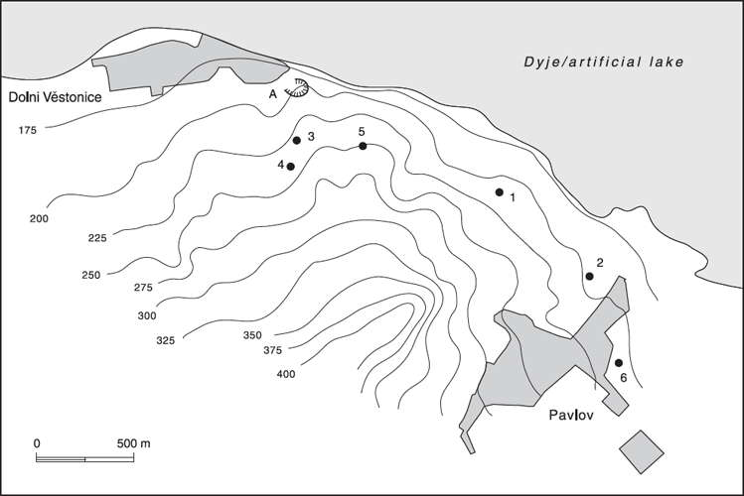Coordinates:** 48.88826 16.64364.

Fig. 2. Relief map showing Upper Paleolithic sites along the northeast side of the Pollau Hill. Dark line is the Dyje River. After Verpoorte (2000). Key: 1. Dolní Věstonice I; 2. Pavlov I; 3. Dolní Věstonice II; 4. Dolní Věstonice II-A; 5. Dolní Věstonice III; 6. Pavlov II.

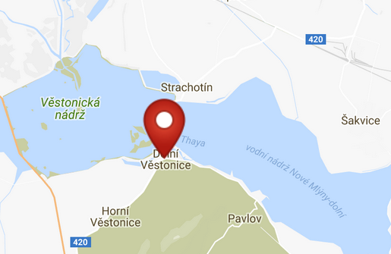 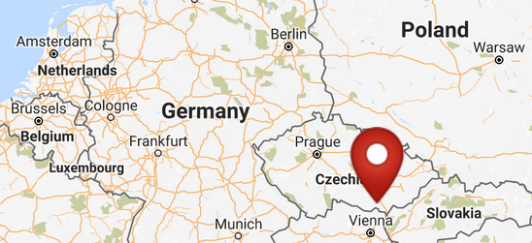

Fig. 3. Map of Dolni Vestonici. Fig. 4. Location of Dolni Vestonici in Europe.

Fig. 5. Map of Dolni Vestonici within Europe. After <http://latitude.to/img/latitude-logo.svg>

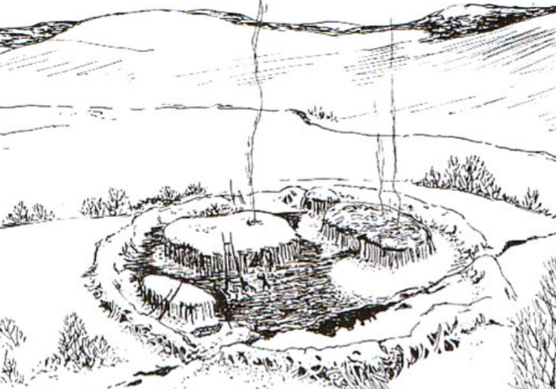

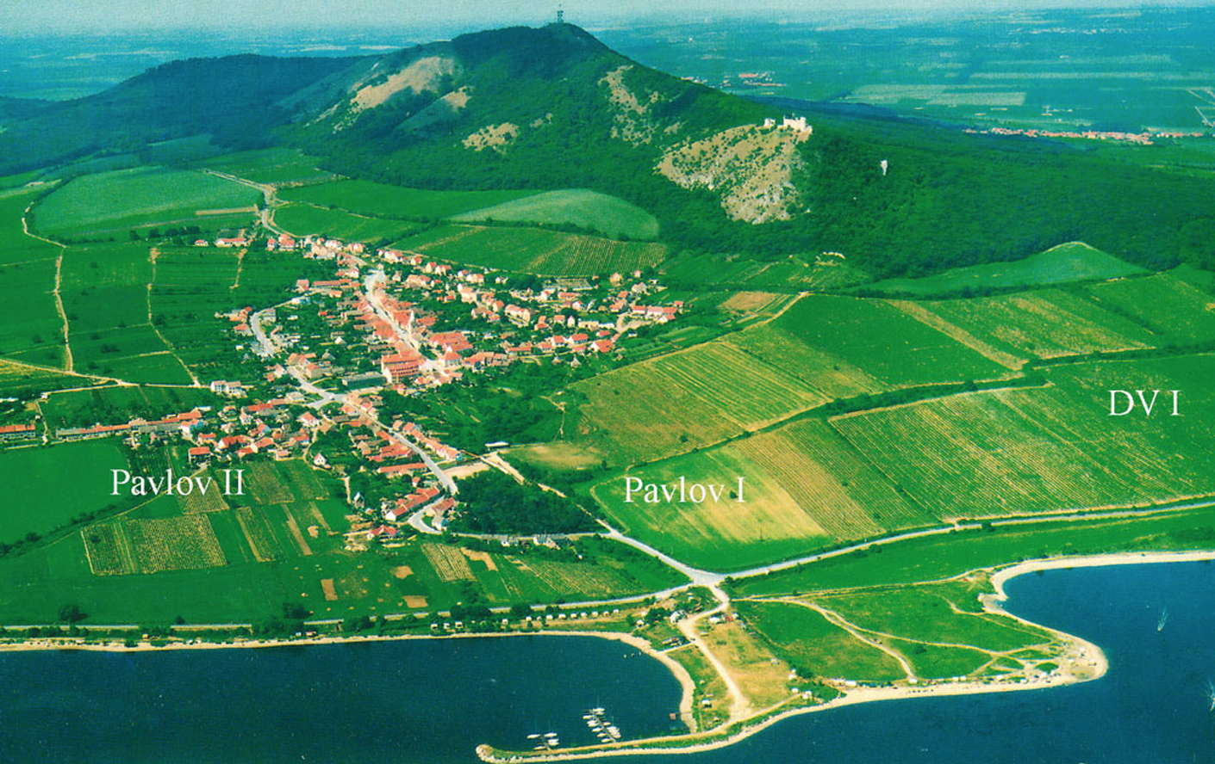

Fig. 6. View of Dolní Věstonice, Moravia, Czech Republic, 29,000 BP, after <http://humanpast.net/images/dolni.JPG>.

Fig. 7. Aerial view of Dolní Věstonice, Moravia, Czech Republic, 2004, after Svoboda (2007)

**Cultural Affiliation:** Gravettian period

**Medium:** burnt clay.

**Dimensions:   
Weight:**

**Provenance: Naturhistorisches Museum in Vienna.**

**Condition:** museum replica in resin.

**Discussion:** This nearly abstract carving of a mammoth provides a glimpse into the initial development of an aesthetic sense of geometric volumes that approach the animal as an artistic entity and not as a rationalistic entity that could be identified by its biology.

**References:**

Trinkaus, Erik and Jiri Svoboda (Eds.) 2005.*Early Modern Human Evolution in Central Europe: The People of Dolní Vestonice and Pavlov* (Human Evolution Series). New York: Oxford University Press.